Task No 01: Show the Output of all Examples mentioned in the Lab.
Example No 01:
Input:
using System;
using System.IO;
using System.Text;
namespace CP_Lab_Tasks
{
class Program
{
static void Main(string[] args)
{
var path = @"C:\Users\ESHOP\source\repos\ConsoleApp1\ConsoleApp1\bin\File.txt";
string content = File.ReadAllText(path, Encoding.UTF8);
Console.WriteLine(content);
}
}
}
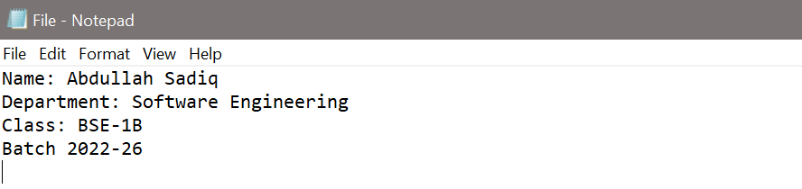
Output:
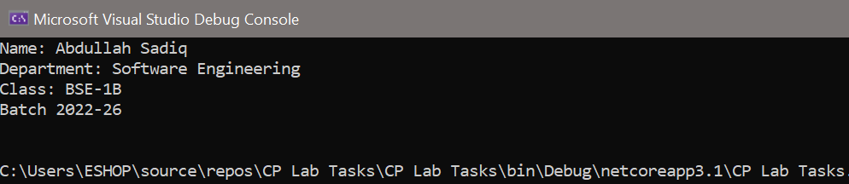
Example No 02:
Input:
using System;
using System.IO;
using System.Text;
namespace ReadAllLines
{
class Program
{
static void Main(string[] args)
{
var path = @"C:\Users\ESHOP\source\repos\ConsoleApp1\ConsoleApp1\bin\File.txt";
string[] lines = File.ReadAllLines(path, Encoding.UTF8);
foreach (string line in lines)
{
Console.WriteLine(line);
}
}
}
}
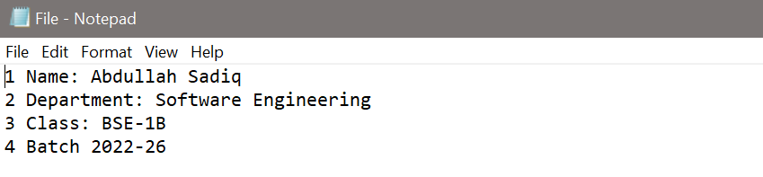
Output:
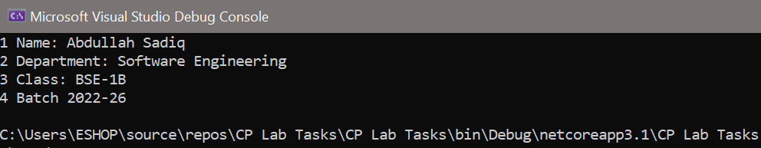
Example No 03:
using System;
using System.IO;
using System.Text;
namespace StreamReaderReadToEnd
{
class Program
{
static void Main(string[] args)
{
var path = @"C:\Users\ESHOP\source\repos\ConsoleApp1\ConsoleApp1\bin\File.txt";
using var fs = new FileStream(path, FileMode.Open, FileAccess.Read);
using var sr = new StreamReader(fs, Encoding.UTF8);
string content = sr.ReadToEnd();
Console.WriteLine(content);
}
}
}
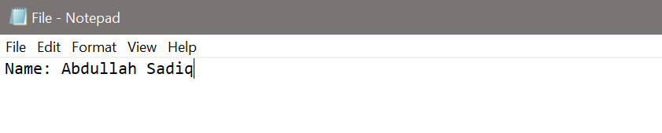
Output:
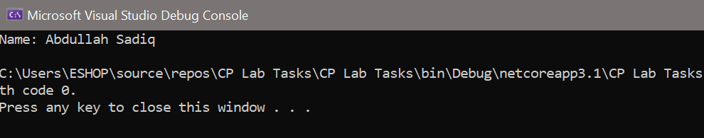
Example No 04:
Input:
using System;
using System.IO;
using System.Text;
namespace ConsoleApp60
{
class Program
{
static void Main(string[] args)
{
var path = @"C:\Users\ESHOP\source\repos\ConsoleApp1\ConsoleApp1\bin\File.txt";
using var fs = new FileStream(path, FileMode.OpenOrCreate, FileAccess.Write);
using (StreamWriter writer = new StreamWriter(fs, Encoding.UTF8))
{
Console.WriteLine("Enter Your Name");
string name = Console.ReadLine();
writer.WriteLine("Name is {0}", name);
}
}
}
}
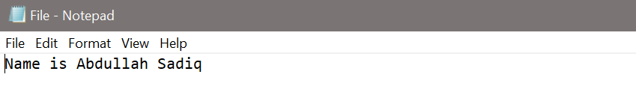
Output:
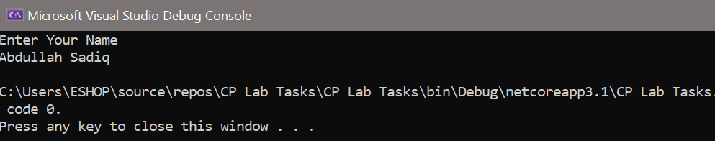

Task No 02: Design a program of Employee in which you must take information of 05 employees. Information includes (employee_id, name, date of birth, email, residential address, job title, salary…etc.) and save all the records in a txt file using Stream Writer.
Input:
using System;
using System.IO;
using System.Text;
namespace CP_Lab_Tasks
{
class Program
{
static void Main(string[] args)
{
int EMPId;
string EMPNAME, EMPDOB, EMPEMAIL, EMPADD, EMPJOB;
double EMPSAL;
string path = @"File.txt";
var fileStream = new FileStream(path,
FileMode.OpenOrCreate, FileAccess.Write);
using (StreamWriter writer = new StreamWriter(fileStream))
{
for (int i = 0; i < 5; i++)
{
Console.WriteLine("Enter {0} Employee Id: ", i + 1);
EMPId = int.Parse(Console.ReadLine());
Console.WriteLine("Enter {0} Employee Name: ", i + 1);
EMPNAME = Console.ReadLine();
Console.WriteLine("Enter {0} Employee Date of Birth: ", EMPNAME);
EMPDOB = Console.ReadLine();
Console.WriteLine("Enter {0} Employee Email: ", EMPNAME);
EMPEMAIL = Console.ReadLine();
Console.WriteLine("Enter {0} Employee Address: ", EMPNAME);
EMPADD = Console.ReadLine();
Console.WriteLine("Enter {0} Employee Job Title:", EMPNAME);
EMPJOB = Console.ReadLine();
Console.WriteLine("Enter {0} Employee Sallary: ", EMPNAME);
EMPSAL = double.Parse(Console.ReadLine());
//now inserting into file
writer.WriteLine(EMPId + " " + EMPNAME + " " + EMPDOB + " " + EMPEMAIL + " " + EMPADD + " " + EMPJOB + " " + EMPSAL);
Console.Clear();
}
}
}
}
}
Output:
